..
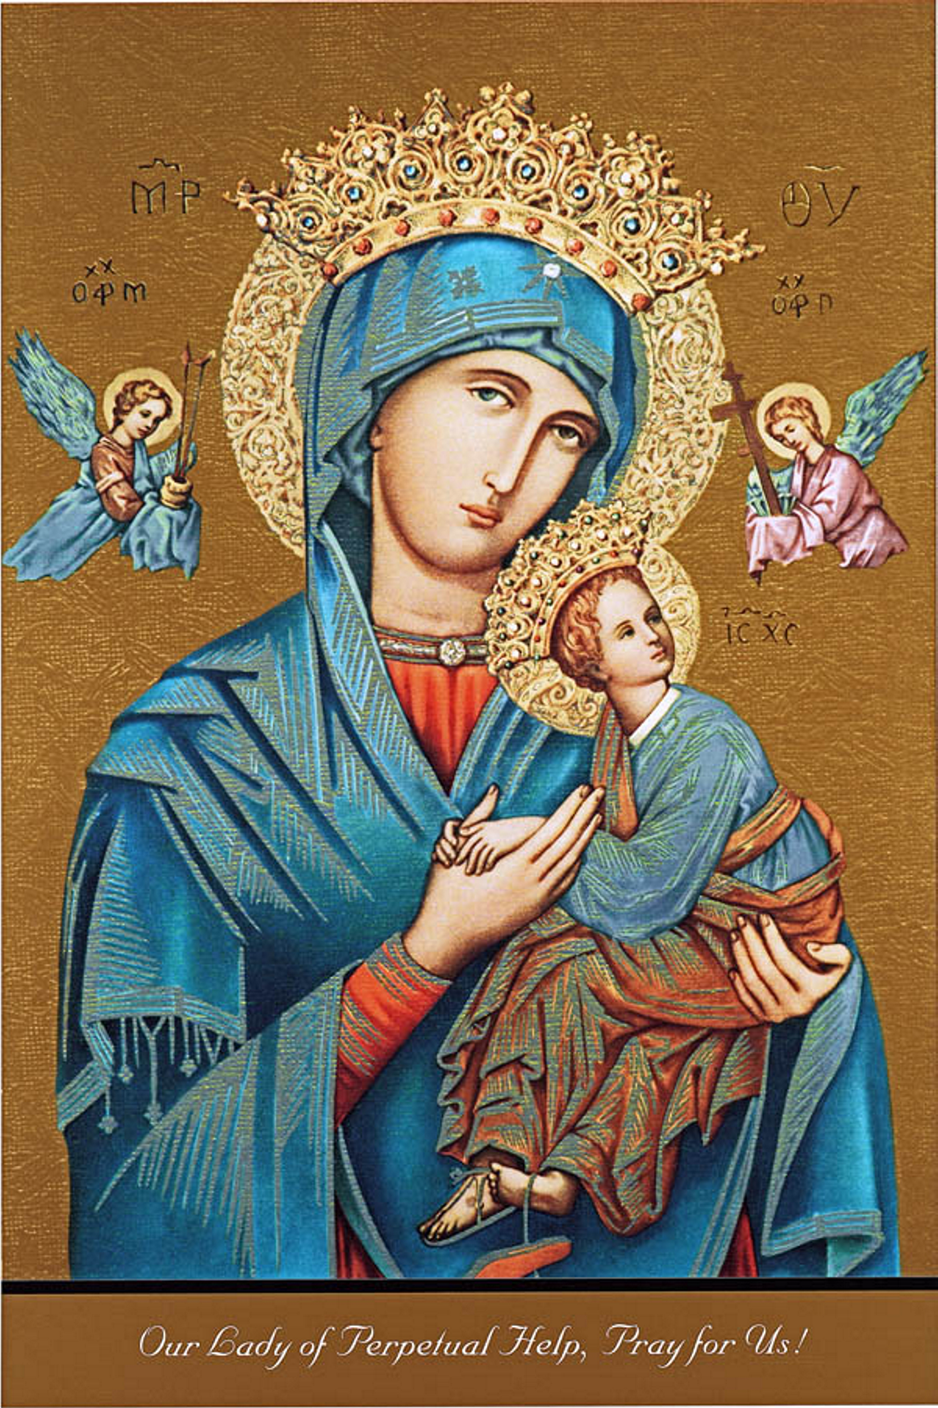 | November 2023
Sun. | Mon. | Tue. | Wed. | Thu. | Fri. | Sat.
October 29 |  | 10-31 | 1 | 2 | 3 | 4
8:30am St Roch  10:30 am St Francis  Mass offered for  Christopher  Discenna |  | Eucharistic Adoration  6:00 pm @ St Roch | 8:45 Bible Study  All Saints Day  Holy Day of obligation  10:00 am @ St Francis  6:00 pm @ St Roch | All Souls Day Mass  10:00 am @ St Felix Cemetery  6:00 pm @ St Roch | First Friday  9:30 am Adoration, Confession & Mass @ St. Roch | First Saturday  9:30 am Adoration, Confession & Mass @ St. Francis  5:00 Mass @  St Roch
5 | 6 | 7 | 8 | 9 | 10 | 11
8:30 am Mass offered for Christopher Discenna  10:30 am Mass  St Francis |  |  | 8:45 Bible Study  10:00 am Mass @ St. Francis | 10:00 am Mass @ St. Roch Mass offered for Pomponi & Discenna  6:30pm Finance & Pastoral Council MTG |  | 4:00 pm Mass  St Roch
12 | 13 | 14 | 15 | 16 | 17 | 18
8:30 am St Roch  Mass offered for  Christopher Discenna  10:30 am Mass @ St Francis |  |  | 8:45 Bible Study  10:00 am Mass @ St. Francis | 10:00 am Mass & after Mass coffee |  | 4:00 pm Mass  St Roch
19 | 20 | 21 | 22 | 23 | 24 | 25
8:30 am Mass offered for Christopher Discenna  10:30 am Mass @  St Francis |  |  | 8:45 am Bible Study  10:00 am Mass @  St. Francis | 10:00 am Mass  @ St. Roch Mass offered for Discenna & Pomponi Deceased |  | 4:00 pm Mass at  St. Roch  Holy Land Carvings  After Mass
26 | 27 | 28 | 29 | 30
8:30 am Mass offered Christopher Discenna  10:30 am Mass offered  MaryJane Voelker  Holy Land Carvings  After Mass  Weekend Mass Schedule:  Saturday Mass 5:00 pm St Roch Church in Caseville  Sunday Mass 8:30 am St Roch Church in Caseville  Sunday Mass 10:30 am St Francis Borgia Church in Pigeon |  | Monthly Eucharistic Adoration & Holy Hour  6:00 -7:00 pm St Roch | 8:45 am Bible study  10:00 am Mass @ St Francis | 10:00 am Mass at St Roch, Mass offered for Deceased of Pomponi & Discenna Family

